

Politecnico di Milano

2015-2016

Software Engineering 2: “MyTaxiService”

Project Plan

version 1.0

Author: Nenad Petrovic

Contents

Function point analysis 3

Classification and counting 3

Complexity and calculations 6

COCOMO approach 11

Scale drivers 13

Cost drivers 17

Effort Equation 25

Schedule estimation 26

Scheduling and resource allocation 27

Risk management 34

# Function point analysis

In this chapter, function point approach is going to be used in order to estimate the project size.

This technique is used for evaluation of project dimension based on functionalities of the application that is going to be developed. The functionalities list is derived using the previously completed RASD document.

Since it is common for computer systems to interact with other computer systems, a boundary must be drawn around each system to be measured prior to classifying components. This boundary must be drawn according to the user’s point of view. In short, the boundary indicates the border between the project or application being measured and the external applications or user domain. Once the border has been established, components can be classified, ranked and tallied.

For each of them, classification is performed to the corresponding category and complexity value is assigned in order to perform the necessary calculation.

## Classification and counting

According to the form of this approach, the functionalities have been grouped in:

* Internal Logical Files (ILF’s) - a user identifiable group of logically related data that resides entirely within the applications boundary and is maintained through external inputs.

Here belongs data that needs to be saved, used and managed inside the application itself. In this case (MyTaxiService), we need to store information about: users, taxi drivers, administrators, reports and drive events.

* External Interface Files (EIF’s) - a user identifiable group of logically related data that is used for reference purposes only. The data resides entirely outside the application and is maintained by another application. The external interface file is an internal logical file for another application.

Here belongs data coming outside the boundaries of MyTaxiService, but is necessary to be used in order to achieve the wanted functionalities – GPS coordinates data, time estimation data, distance estimation data, person code data, driving license data, car id data.

GPS coordinates data, time estimation and distance estimation data is obtained from external GPS services, while the rest (person code, driving license, car id) is obtained from city government database, so this data could be generally divided into two categories – GPS data and government data.

* External Inputs (EI) - is an elementary process in which data crosses the boundary from outside to inside. This data may come from a data input screen or another application. The data may be used to maintain one or more internal logical files. The data can be either control information or business information. If the data being considered is control information it does not have to update an internal logical file.  The graphic represents a simple EI that updates 2 ILF's (FTR's).

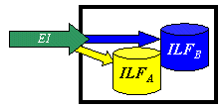

Here input operations belong operations – log in, log out, register, profile modification, taxi request, delete users, update to taxi drivers, downgrade drivers, write report, request taxi, drive response request, drive offer response, manual taxi availability change.

* External Inquiry (EQ) - an elementary process with both input and output components that result in data retrieval from one or more internal logical files and external interface files. The input process does not update any Internal Logical Files, and the output side does not contain derived data. The graphic below represents an EQ with two ILF's and no derived data.

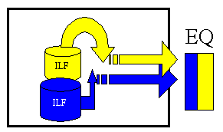

Here belong the following inquires: profile information visualization, view report, view drive, browse users, view user, visualize drive event, view offer/request summary.

.

* External Outputs (EO) - an elementary process in which derived data passes across the boundary from inside to outside. Additionally, an EO may update an ILF. The data creates reports or output files sent to other applications. These reports and files are created from one or more internal logical files and external interface file.  The following graphic represents on EO with 2 FTR's there is derived information (green) that has been derived from the ILF's

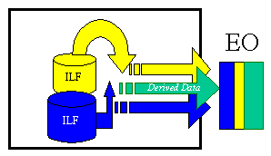

Here belongs the taxi zone determination, cost estimation and taxi dispatching.

This data is available to developers using MyTaxiService API that is previously described.

## Complexity and calculations

The following table outline the number of Functional Point based on funtionality and relative complexity:

|  |  |  |  |
| --- | --- | --- | --- |
| Function Type |  | Complexity | |
| Simple | Medium | Complex |
| Internal Logic File | 7 | 10 | 15 |
| External Interface File | 5 | 7 | 10 |
| External Input | 3 | 4 | 6 |
| External Output | 4 | 5 | 7 |
| External Inquiry | 3 | 4 | 6 |

Using the Function Points method, the estimation of the effort required to complete the application depends on the functionalities the application has to offer. Specifically, the number of FPs can be computed as the weighted sum of function types using the coefficient of the table above. In what follows, the calculation is performed step by step:

* Internal Logic Files (ILFs):

The application includes a number of ILFs that will be used to store the information about users, taxi drivers, administrators, reports and drive events.

Each of these entities has medium structure complexity as it is composed of a medium number of fields except for administrators and reports, which have simple structure with small number of fields.

This means that we will come out with 3 x 10 + 2 x 7= 30 + 14 = 44 FPs concerning

ILFs.

* External Interface Files (EIFs):

The application features two categories of EIFs – GPS data (coordinates, time, distance) and government data (person code, car id, driving license). The first is considered with medium complexity, while second is simple.

The result is: 3 x 7 + 3 x 5 = 21 + 15 = 36 FPs

* External Inputs (EIs)

The application interacts with the different types of users to allow them to log in, log out, register, profile modification, taxi request, delete users, update to taxi drivers, downgrade drivers, write report, drive request response, drive offer response, manual taxi availability change.

* + Login/logout: these are simple operations, so we can adopt the simple weight for them. 2 x 3 = 6 FPs
  + Register: this is a medium operation, so (involves check with external interface file) we can adopt the medium weight. 1 x 4 = 4 FPs
  + Profile modification: this is also a simple operation: 1 x 3 = 3 FPs
  + Taxi request: this is a complex operation because it includes many sub-operations 1 x 6 = 6 FPs
  + Offer/taxi request response: these are two medium complexity operations 2 x 4 = 8 FPs
  + Write report: simple operation 1 x 3 = 3 FPs
  + Update to taxi driver: complex operation, because involves data input, data check, and many entities are involved: 1 x 6 = 6 FPs
  + Downgrade taxi driver: medium operation 1 x 4 = 4 FPs
  + Manual taxi availability change: simple 1 x 3 = 3 FPs
  + Delete user: simple 1 x 3 = 3 FPs

The sum is: 6 + 4 + 3 + 6 + 8 + 3 + 6 + 4 + 3 + 3 = 46 FPs

* External Output (EO)

Here belongs the taxi zone determination, cost estimation and taxi dispatching. Each of these operations is quite complex, because it involves mathematical calculations (taxi zone determination, cost estimation) and usage of algorithms and data structures in order to create external output (taxi dispatching uses taxi queues and operations). So, here we will have the total number of function points:

3 x 7 = 21 FPs

* External Inquiries (EQ)

Here belong the following inquires: profile information visualization, view report, view drive, browse users, view user, visualize drive event (realtime), view offer/request summary.

- Profile information visualization: simple 1 x 3 = 3 FPs

- View report/drive: medium complexity, involves many entities 2 x 4 = 8 FPs

- View user/browse users: simple 2 x 3 = 6 FPs

- Visualize drive event (realtime): complex, involves usage of many enitites : 1 x 6 = 6 FPs

- View offer/request summary: medium 2 x 4 = 8 FPs

Sum: 3 + 8 + 6 + 6 + 8 = 31 FPs

* UFP calculation

Finally, we sum previously calculated results : 44 + 36 + 46 + 21 + 31 = 178 FPs.

This value can be used directly to estimate the effort in case we have some historical data that tell us how much time we usually take for developing a FP. Otherwise, it can be used as a basis to estimate the size of the project in KLOC and then use another approach such as COCOMO for effort estimation.

|  |  |  |  |  |
| --- | --- | --- | --- | --- |
| Category | Simple | Medium | Complex | Sum [FPs] |
| ILF | * Admin * Drive event * Report | * User * Driver |  | 44 |
| EIF | * Fiscal codes * Car ID * Driving license | * Coordinates * Distance * Time |  | 36 |
| EI | * Login * Log out * Profile modification * Write report * Delete user * Availability change | * Downgrade driver * Register * Offer response * Request response | * Update to driver * Taxi request | 46 |
| EO |  |  | -taxi zone determination  -cost estimation  -dispatching | 21 |
| EI | - profile info visualization  - view user  - browse users | - view report  -view drive  - view request summary  - view response summary | -visualize drive event | 31 |
| Total |  |  |  | 178 |

# COCOMO approach

In this chapter, COCOMO (<http://csse.usc.edu/csse/research/COCOMOII/cocomo2000.0/CII_modelman2000.0.pdf>) approach is used in order to estimate the effort and time needed to develop MyTaxiService. First, using results from previous FP calculations and statistics for project size, the size of the project is going to be estimated in source lines of code (SLOC). After that, effort is going to be calculated in number of persons/months. When effort calculation is completed, the result is used in order to estimate the project duration in months, and, finally, using previous two results (effort and duration) – the number of people needed to work on project is calculated.

The exponent E in equation is an aggregation of five *scale factors* (SF) that account for the relative economies or diseconomies of scale encountered for software projects of different sizes [Banker et al. 1994].

If E < 1.0, the project exhibits economies of scale. If the product’s size is doubled, the project effort is less than doubled. The project’s productivity increases as the product size is increased. Some project economies of scale can be achieved via project-specific tools (e.g., simulations, testbeds), but in general these are difficult to achieve. For small projects, fixed start-up costs such as tool tailoring and setup of standards and administrative reports are often a source of economies of scale.

If E = 1.0, the economies and diseconomies of scale are in balance. This linear model is

often used for cost estimation of small projects.

If E > 1.0, the project exhibits diseconomies of scale. This is generally because of two main factors: growth of interpersonal communications overhead and growth of large-system integration overhead. Larger projects will have more personnel, and thus more interpersonal communications paths consuming overhead. Integrating a small product as part of a larger product requires not only the effort to develop the small product, but also the additional overhead effort to design, maintain, integrate, and test its interfaces with the remainder of the product. See [Banker et al. 1994] for a further discussion of software economies and diseconomies of scale.

Cost drivers are used to capture characteristics of the software development that affect the effort to complete the project. A cost driver is a model factor that "drives" the cost (in this case Person-Months) estimated by the model. All COCOMO II cost drivers have qualitative rating levels that express the impact of the driver on development effort. These ratings can range from Extra Low to Extra High. Each rating level of every multiplicative cost driver has a value, called an effort multiplier (EM), associated with it. This scheme translates a cost driver's qualitative rating into a quantitative one for use in the model. The EM value assigned to a multiplicative cost driver's nominal rating is 1.00. If a multiplicative cost driver's rating level causes more software development effort, then its corresponding EM is above 1.0.

First, let’ consider the case with nominal values, and after that the case with derived values from customized scale and cost drivers.

To pass from FP to SLOC we use an average conversion factor of 46 as described at [http://www.qsm.com/resources/function-point-languages-table,](http://www.qsm.com/resources/function-point-languages-table)

178 *FPs* ∗46 = 8188 *SLOC*

A first estimation is based on FPs approach converted to SLOC. We Consider a project with all “Nominal” ost Drivers and Scale Drivers would have an EAF of 1.00 and exponent E of 1.0997. Following this formula

*effort* = 2*.*94∗ *EAF* ∗(*KSLOC*)*E*

we obtain *effort* = 2*.*94∗(1*.*0)∗(8*.*188)1*.*0997 = 29*.*687 *Person-Months*

EAF: Effort Adjustment Factor derived from Cost Drivers.

E:Exponent derived from Scale Drivers.

Now we calculate the schedule (duration) of project in month with the following formula

*Duration* = 3*.*67∗(*effort*)*E*

We consider an exponent E of 0.3179

*Duration* = 3*.*67∗(29.687)0*.*3179 = 10*.*784 *Months*

Now we can estimate the number of people needed to complete the project with the following formula

*Npeople* = *effort/Duration*

*Npeople* = 29*.*687*/*10*.*784 = 3 *persons*

Almost 30 person-months looks like a very big value for this project. This is a result of nominal value which are rough approximation and can’t be taken as precise estimation.

So, in what follows, more precise calculation is going to be performed, using scale and cost drivers that take values specific to this project and real situation.

## Scale drivers

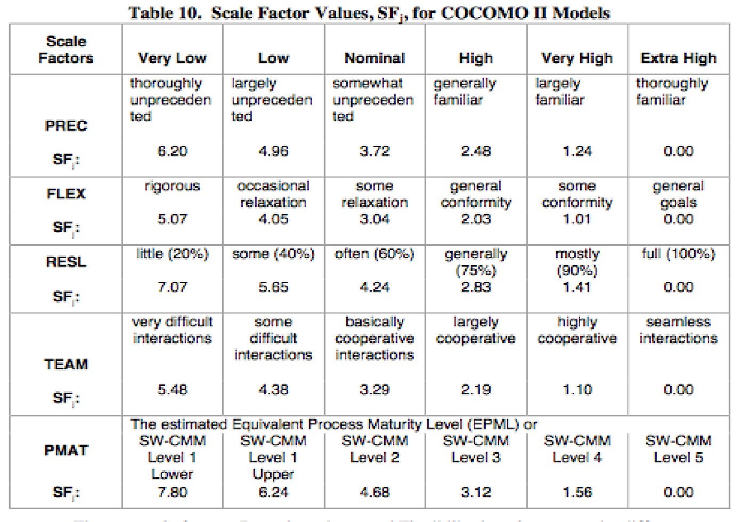These values are evaluated according to the following table:

* Precedentedness:

It reflects the team’s previous experience with this kind of projects. Since for this team it was the first experience using this framework and these development methodologies, such as J2EE and Android, this value will be low.

* Development flexibility:

It reflects the degree of flexibility in the development process. The teachers and teaching assistants constructed the assignments giving the general specifications without going too much in details, making this project development very flexible, so, for this reason this value is going to be set to high – general conformity.

* Risk resolution:

Reflects the extent of risk analysis carried out. This value will be high ,considering this project.

* Team cohesion:

Reflects how well the development team know each other and work together. Let’s assume that this is team’s first project and that they didn’t know each other previously. Also, let’s assume that there are synchronization problems, such as different academic assignments during project for each of the members. So, this driver will be high – largely cooperative.

* Process maturity:

This was evaluated around the 18 Key Process Area (KPAs) in the SEI Capability Model.

There are five levels of process maturity, level 1 (lowest half) to level 5 (highest). The CMM specifies “what” should be in the software process rather than “when” or “for how long”.

The CMM level 1 is for organizations that don‟t focus on processes or documenting lessons learned. The CMM level 1 is for organizations that have implemented most of the requirements that would satisfy CMM level 2. In CMM‟s published definition, level 1 (lower half) and (Upper half) are grouped into level 1.

To be rated at a particular level, the organization should demonstrates capabilities in a set of Key Process Areas associated with a specific CMM level. The capabilities demonstrated in moving from lower levels to higher levels are cumulative. For example, level 3 organizations should show compliance with all key process areas in levels 2 and 3. The CMM process maturity framework is presented in Table.

Because of the goals were consistently achieved these values will be set to high, level 3.

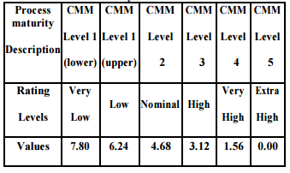

Using the formula below to calculate the exponent factor value from scale drivers:

E= B + 0.01× ∑ SFj,

where we have constant B=0.91.

The results are resumed in the following table:

|  |  |  |
| --- | --- | --- |
| *Scale Driver* | Factor | *Value* |
| Precedentedness | Low | 4.96 |
| Development Flexibility | High | 2.03 |
| Risk Resolution | High | 2.83 |
| Team Cohesion | High | 2.19 |
| Process Maturity | High | 3.12 |
| Total: |  | 15.13 |
| E= B + 0.01× ∑ SFj |  | 1.0613 |

Using the previously obtained Total(SD) from the table, the factor E (exponent) is calculated:

E=0.91+ 0.01 x Total(SD)=0.91 + 0.01 x 15.13 = 1.0613

## Cost drivers

In this chapter, cost drivers are going to be analyzed in order to determine the EAF. The Effort Adjustment Factor in the effort equation is simply the product of the effort multipliers corresponding to each of the cost drivers for our project.

* Required Software Reliability:

According to RASD and the nature of this project itself, the reliability parameter is important (deals with real-world traffic, taxi driver profit, passengers and taxi drivers). Software failures don't have critical consequences in most cases, and the that would risk human life, so this could be set to high – due to possible loss of users (not satisfied with service) and taxi drive opportunities (financial loss).

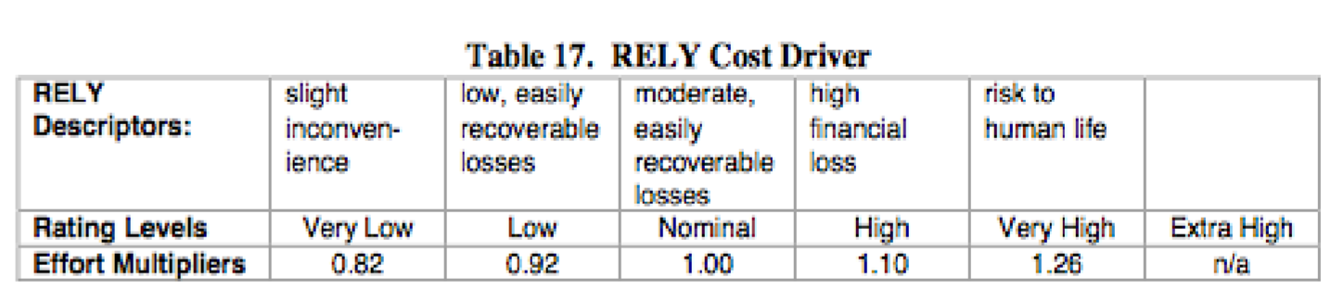

* Data Base Size:

It translates the effects that large data have in our application.

Let’s assume that test database size is equal to 512.0 KB and the program size is equal to 8188 SLOC, the division:

D/P = 15.99 and then this parameter has a nominal value, since it is between 10 and 100 (according to the table below).

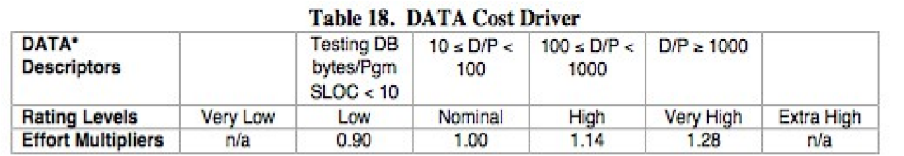

* Product Complexity:

Set to high according to the new COCOMO II CPLEX rating scale.

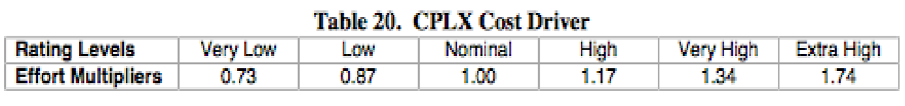

* Required Reusability:

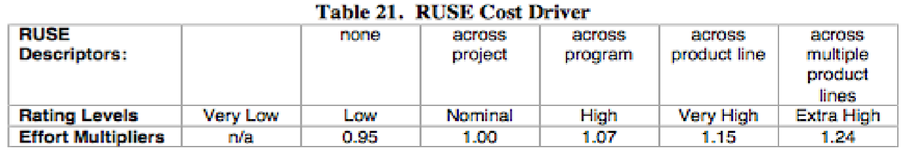In our project there are different reusable components since the aim was to design the system as modular as possible (common functionalities for all types of users). Also, it should be taken into account that for API development high reuse of previously developed components is going to be performed, so this parameter is therefore set to high.

* Documentation match to life-cycle needs:

This parameter describes the relation between the provided documentation and the application requirements.

In our system to be described has been expressed in the RASD and in the DD.

On the other hand, it should be taken into account that code inspection was assignment not really related to this project and unit testing hasn’t been performed. Also, the important thing is that, no implementation is performed and many lifecycle phases are not covered by the documentation.

But, for this calculation, it is assumed that implementation is going to be performed, so this value is low, because not all phases are covered entirely.

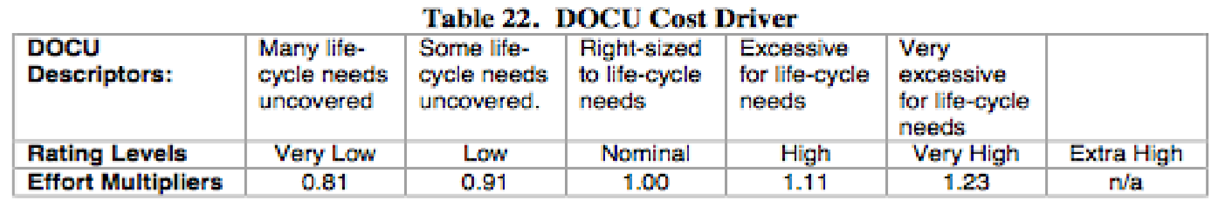

* Execution Time Constraint:

As stated in RASD, there are many assumptions, limitations and constraints, so thi is set to high.

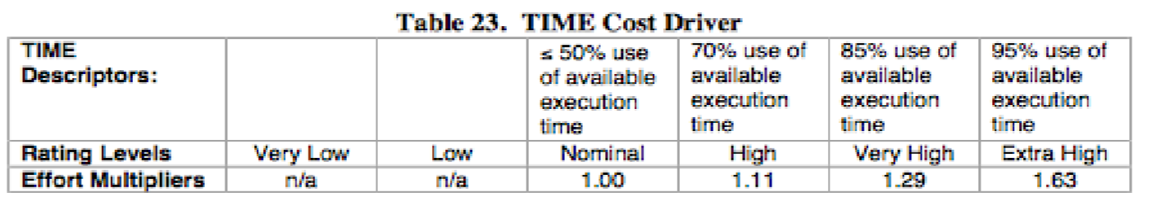

* Main Storage Constraint: This parameter represents the degree of main storage constraint. In our application this parameter is not relevant (because the application doesn’t need much storage), so this parameter won’t be taken into account.

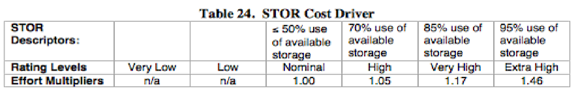

* Platform Volatility:

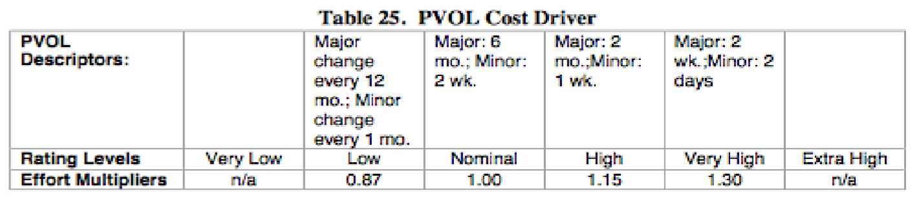

In our application is reasonable to consider as platforms the DBMS, the operating system, the browser, and the hardware as far as the environment concerns and compiler. The platform shouldn’t change, but updates are expected.

But, considering the mobile counterpart of the application, both operating system and environment minor changes are expected (Android updates, Android Studio instead of Eclipse integration, etc.) so, the overall result is nominal, because the expected changes are natural.

* Analyst capability

A lot of effort was put in problem analysis (since, in reality, the complete assignment consists of documentation only, not of implementation) - analysis of the problem requirements, design and its potential integration if it had been developed, even the model correctness proof was performed using Aloy language.

Taking all these facts into account, the value should be set to very high. 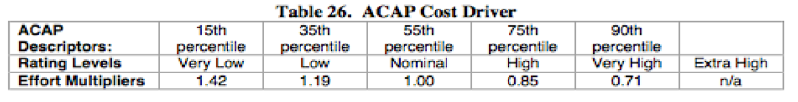

* Programmer Capability: This value is set to high and estimated as an overall result in cooperation and individual programming skill.

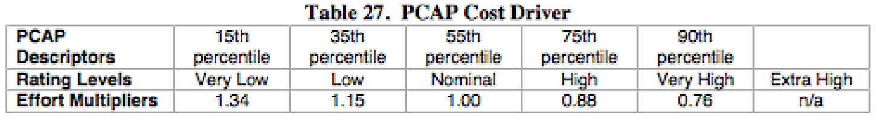

* Application Experience:

Our project experience is evaluated according to our previous experience in web and database- oriented project and also according to our abilities in programming in Java and most importantly in the Java EE framework.

Since the members have already successfully completed many projects in Java, have constructed many complete web sites and have more than 10 database-oriented applications in portfolio during past 3 years.

Our average knowledge about platforms as: databases, user interfaces and server side development are around 3 years (Databases, Databases 2, Advanced Databases, DBMS, Human-Computer interaction, Web programming, courses), so this parameter is set as high.

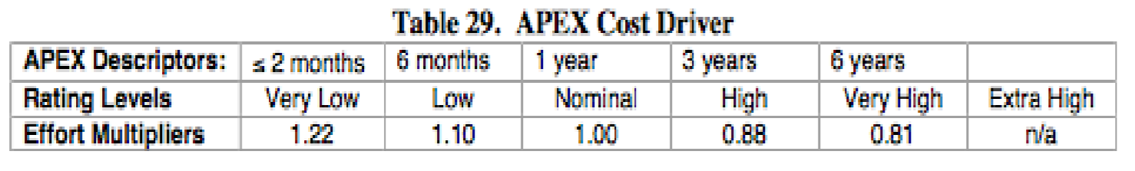

* Platform Experience:

This is set to high, because we haven’t done previously any project with combination of these tools (Java EE and Android studio), but our knowledge and experience is high enough to deal with them.

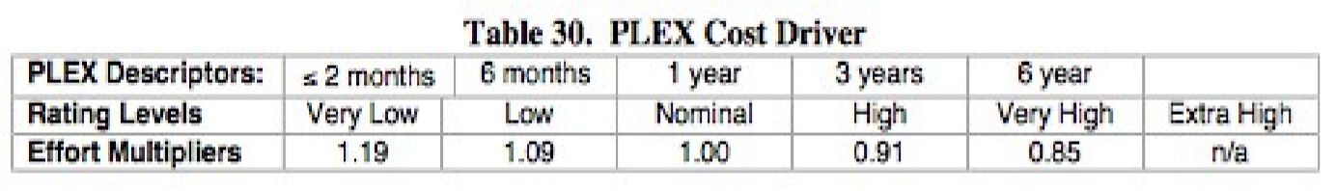

* Language and Tool Experience:

This parameter reflects the experience that is a consequence (in particular of previous two), so this is set to high, due to experience with Java programming language and Eclipse development.

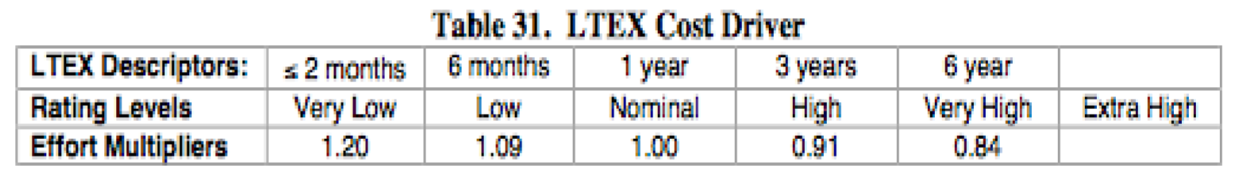

* Personnel continuity:

This parameter is relevant in particular since in the current case our available time is less than half a year (1/2 of October, November, December, January, beginning of February) . For this reason we set it to very low.

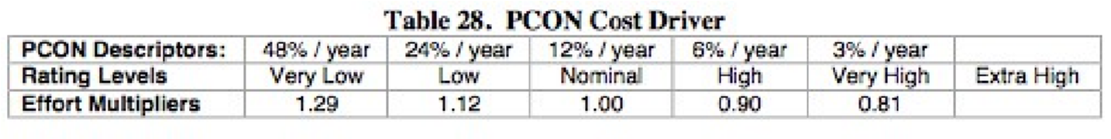

* Usage of Software Tools:

Eclipse and Android Studio were used to manage dependencies of our project as libraries and development kits and Git for the repository management.

The most appropriate value is high.

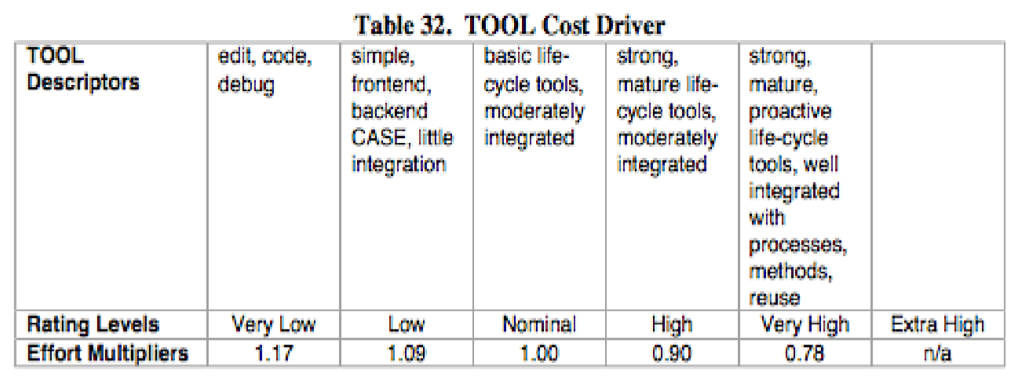

* Multisite development:

This parameter is projection of how the team members have handled the distribution of development over distance and multiple platforms.

The team members used mobile phones, e-mail, Skype and Facebook (chat, file exchange, messenger calls, video calls) for communication and file exchange, and GitHub for version and changes management.

Considering a wide variety of different highly interavctive technologies used, this value is set to extra high (interactive multimedia).

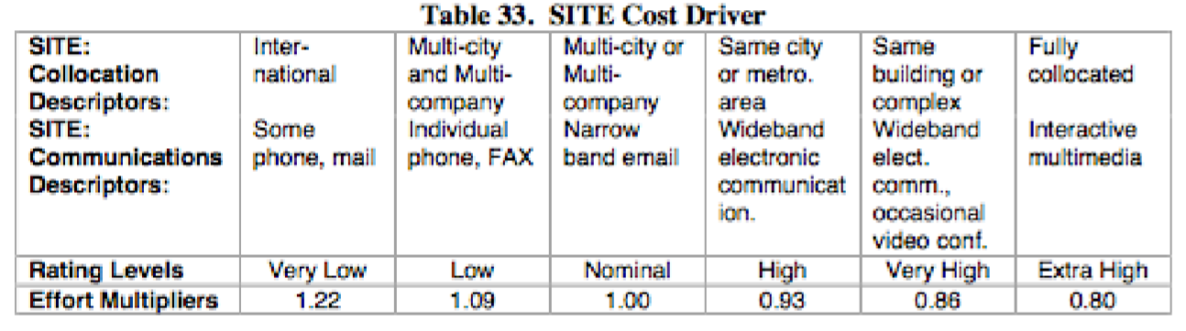.

* Required development schedule:

It was aim to distributed well over the available development time, but regardless of this fact, the implementation required high efforts at the later phases.

The problem formulation was extended by some requirements that would improve usage of this system in real world, and some minor things were adapted later. For these reason this parameter should be set to high.

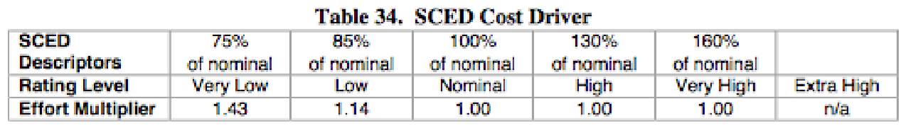

In what follows, a table overview of the selected values for cost drivers is provided.

|  |  |  |
| --- | --- | --- |
| *Cost Driver* | Factor | *Value* |
| Required Software Reliability | High | 1.10 |
| Data Base Size | High | 1.00 |
| Product Complexity | High | 1.17 |
| Required Reusability | High | 1.07 |
| Documentation match to life-cycle needs | Low | 0.91 |
| Execution Time Constraint | High | 1.11 |
| Main Storage Constraint | Very Low | n/a |
| Platform Volatility | Nominal | 1.00 |
| Analyst Capability | Very High | 0.71 |
| Programmer Capability | High | 0.88 |
| Application Experience | High | 0.88 |
| Platform Experience | High | 0.91 |
| Language and Tool Experience | High | 0.91 |
| Personnel continuity: | Very Low | 1.29 |
| Usage of Software Tools | High | 0.90 |
| Multisite development | Extra High | 0.80 |
| Required development schedule | High | 1.00 |
| Product (EAF): |  | 0.59 |

## Effort Equation

After getting the values for both E and EAF, this final equation gives us the effort estimation measured in Person-Months (PM)

Effort := A * EAF * KSLOC E

Where:

|  |
| --- |
| A → 2.94 (for COCOMO.2000)  EAF → product of all the cost drivers, equal to : 0.59 ;  E → exponent derived from Scale Drivers. Is calculated as:  B + 0.01 * sum{i} SF[i] := B + 0.01 *15.13 = 0.91 + 0.1371 = 1.0613; in which B is equal to: 0.91 for COCOMO.2000 .  KSLOC → estimated lines of code using the FP analysis: 8.188 |

With this parameters we can compute the Effort value, that is equal to:

Effort := 2.94 * 0.59 * 8,188 1.0613 = 16.157 *Person-Months*.

In conclusion , we could say that this value slightly differs from value obtained using all the nominal values (29*.*687 *Person-Months*), and looks much closer to reality.

Such result was expected due to much more things taken into account, deriving the values that correspond to custom project.

## Schedule estimation

As far as the schedule estimation we are going to use the following formula:

Duration := 3.67 * Effort F

Where:

F := 0.28 + 0.2 * ( E – B ) = 0.28+ 0.2*(1.0613-0.91) = 0.28 + 0.31026

Follows then:

Duration := 3.67 * 16.157 0.31026 = 8.7

The duration calculated here is not even close to the actual time we had to our disposal for this project, that could be estimated being around 3.5 months. There are then two possibilities:

* Some of the estimations we made are not appropriate for the actual problem we are analyzing
* In reality the implementation part was not performed

The number of people required should be 16.157/8.7 = 1.4 . It means that 2 persons are more than enough for this project (compared to 3 persons using nominal values previously) .

# Scheduling and resource allocation

This chapter deals with project planning related to task scheduling and human resources allocation.

The project consists of 6 main parts, as seen below.

Project planning deals with scheduling, team engagement and resource allocation. After having this part done, project plan is completed and them is ready to start project.

Requirements analysis and specification results in RASD document which is, along Design document, the crucial part of the project. Implementation is parallel with System architecture and design, and uses decisions brought about architecture in design document, After that, the testing is performed. When some test fails, implementation is performed again (related to this part that was considered). Afterwards, if all tests passed, project finalization is done: executable application, manual and documents are delivered in definite versions and project could be presented to public or stakeholders.

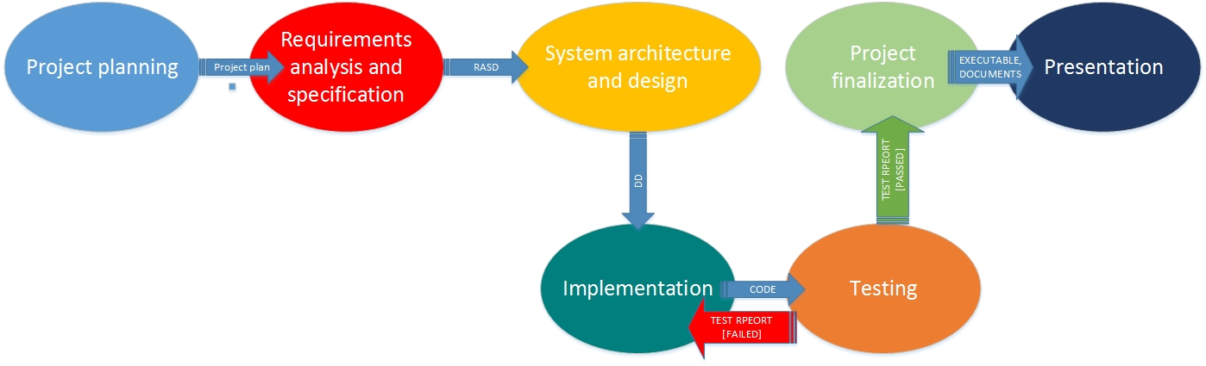

The following terminology is going to be used:

**Tasks** are activities which must be completed to achieve the project goal. Phases are dividied in tasks, which shouldn’t be long (maximum week or two).

**Milestones** are points in the schedule against which you can assess progress, for example, the handover of the system for testing.

**Deliverables** are work products that are delivered to the customer (for example, design document).

First, the project is going to be broken down into tasks. They are denoted as T1,T2…TN.

Each of the tasks has starting and ending date (duration). It could have milestones – M1,M2…Mn and deliverables denoted as D1,D2,…DN.

Dependencies stand for tasks or deliverables that must be completed before the considered task starts.

Last three columns are percentage of participation of each of the named members in given task. For example, 0 or empty field mean that members is not involve in this task, while 100 means that the member does it alone.

A few words about team members.

According to the calculations (COCOMO), more than 2 persons are needed. So, the team will consist of highly-experienced project manager (5 years in industry), Expert (more than a decade) and Junior, who is a fresh computer science graduate.

Nenad is highly-experienced member of the team and is project manager. He is also skilled in programming, software and graphical design, but not in mobile applcaition development. He is the one who is the most responsible for the deliverables.

Expert is member with highest experience (more than a decade in software industry) and is hired by Nenad for this project. This member is not involved into all phases of project, because his work is costly. But, he is crucial in requirements analysis, architecture/algorithm design phases, which are the the most important for future development. He is not involved in implementation phase, because his labor costs too much to spend money on this – there is a junior member that will do this.

Junior member is newcomer, so he is the least experienced and skilled, but has enough experience and skill in programming and mobile application development, so he will be the most responsible for mobile app development part. He will also actively participate in testing, but will participate less in architecture design-related tasks. His knowledge and experience are, though, enough for deriving use case diagrams from specifications and sequence diagrams. He will also help Nenad in implementation of the system. This project is opportunity for junior member to obtain new knowledge and skills also, participating in design process by some percentage and requirements analysis.

|  |  |  |  |  |  |  |  |  |  |  |
| --- | --- | --- | --- | --- | --- | --- | --- | --- | --- | --- |
| Task | | | Starting date | Ending date | Dependencies | Deliverables | Milestone | N  E  N  A  D | E  X  P  E R T | J  U  N  I  O  R |
| T1 – Team formation and planning | | | 7-10-2015 | 14-10-2015 |  | D1 – Project plan |  | 100 |  |  |
| T2 – Requirements analysis | | | 15-10-2015 | 27-10-2015 |  |  | M1 – Goals, assumptions, constraint | 25 | 50 | 25 |
| T3 – GUI concept design | | | 18-10-2015 | 21-10-2015 | T2(M1) |  | M2 - Mockups, State transition diagram | 50 |  | 50 |
| T4 – Use cases | | | 22-10-2015 | 25-10-2015 | T3(M2) |  | M3 - Use case diagrams, Requirements level class diagram | 30 |  | 70 |
| T5- Scenarios identification and description | | | 26-10-2015 | 29-10-2015 | T4(M3) |  | M4 – Sequence diagrams | 50 |  | 50 |
| T6 – Model Verification | | | 30-10-2015 | 3-11-2015 | T4(M3), T5(M4) |  | M5 - Alloy model | 50 | 25 | 25 |
| T7 – RASD document completion | | | 4-11-2015 | 06-11-2015 | T2(M1),T3(M2),T4(M3), T5(M4) | D2 - RASD document |  | 25 |  | 75 |
| T8 – Architectural design | I  M  P  L  E  M  E  NT  A  T  IO  N |  | 07-11-2015 | 15-11-2015 | T7 (D2) |  | M6 – High level components diagram | 25/50/0 | 50/0/0 | 25/25/0 |
| T9 – Interface specification | 16-11-2015 | 23-11-2015 | T7(D2), T8(M6) |  | M7 – Component, deployment and runtime view diagrams, sequence diagrams | 50/50/0 | 25/0/0 | 25/50/0 |
| T10 a– Algorithm design | M  O  B  I  L  E  A  P  P | 24-11-2015 | 28-11-2015 | T7(D2) |  | M8a – Algorithm diagrams | 30/25/0 | 70/0/0 | 10/0/75 |
| T10b – Database design | 29-11-2015 | 30-11-2015 | T7(D2) |  | M8b – Database schema | 50/50/0 |  | 50/50/100 |
| T11 – Design document completion | 1-12-2015 | 4-12-2015 | T8 (M6), T9(M7) | D3 – Design document  D4 – application code |  | 100/50/0 |  | 0/50/100 |
| T12 – code inspection | | | 5-12-2015 | 12-12-2015 | IMPLEMENTATION, MOBILE APP (D4) | D5- Code inspection document |  | 50 |  | 50 |
| T13 – unit test planning | C  O D E  C O R R E C T I O N | | 13-12-2015 | 20-12-2015 | T7(D2), T11(D3) |  | M9 – test cases and specification | 50/50 |  | 50/50 |
| T14 – unit test | 21-12-2015 | 23-12-2015 | T13(M9) |  | M10 – unit test report | 50/50 |  | 50/50 |
| T15 – integration test planning | 26-12-2015 | 31-12-2015 | T14 |  | M11 –integration test cases and procedure | 50/50 |  | 50/50 |
| T16 – integration test | 2-1-2016 | 5-01-2016 | T15(M11) |  | M12 – integration test report | 50/50 |  | 50/50 |
| T17 – System test planning | 10-1-2016 | 12-01-2016 | T16 |  | M13 – system test specification and cases | 50/50 |  | 50/50 |
| T18 – System test | 14-1-2016 | 18-01-2016 | T17(M13) |  | M14 – system test report | 50/50 |  | 50/50 |
| T19 – Acceptance test planning | 19-01-.2016 | 24-01-2016 | T18 |  | M15 – acceptance test specification | 50/50 |  | 50/50 |
| T20 - Acceptance test | 25-01-2016 | 27-01-2016 | T19(M15) |  | M16 – acceptance test report | 50/50 |  | 50/50 |
| T21 – Test document preparation | 28-01-2016 | 30-01-2016 | T13-T20 | D6 – Test document,  D7 – Release version build |  | 100/0 |  | 0/100 |
| T22 – User manual preparation | | | 31-01-2016 | 02-02-2016 | T21(D7) | D8 – User manual |  | 50 |  | 50 |
| T23 – Presentation preparation | | | 03-02-2016 | 05-02-2016 |  | D9 – My Taxi Service presentation |  | 50 |  | 50 |

In what follows, table representation of this information related to MyTaxiService project is given using a table.

In what follows, tasks are displayed against time as chart. Each slot (square) lasts 3.5 days in average. Red, blue, green and dark yellow are used to display when task is performed. Gray means that these days are holidays or non-working days: Catholic Christmas, New Year, Orthodox Christmas and Orthodox New Year. Names of tasks are given in enumeration form in order to keep clarity of the chart.

|  |  |  |  |  |  |  |  |  |  |  |  |  |  |  |  |  |  |  |  |  |  |  |  |  |  |  |  |  |  |  |  |  |  |  |  |  |
| --- | --- | --- | --- | --- | --- | --- | --- | --- | --- | --- | --- | --- | --- | --- | --- | --- | --- | --- | --- | --- | --- | --- | --- | --- | --- | --- | --- | --- | --- | --- | --- | --- | --- | --- | --- | --- |
|  | 07.10.2015. |  |  |  |  |  |  |  |  |  |  |  |  |  |  |  |  |  |  |  |  |  |  |  |  |  |  |  |  |  |  |  |  |  |  | 05.02.2016 |
| T1 |  |  |  |  |  |  |  |  |  |  |  |  |  |  |  |  |  |  |  |  |  |  |  |  |  |  |  |  |  |  |  |  |  |  |  |  |
| T2 |  |  |  |  |  |  |  |  |  |  |  |  |  |  |  |  |  |  |  |  |  |  |  |  |  |  |  |  |  |  |  |  |  |  |  |  |
| T3 |  |  |  |  |  |  |  |  |  |  |  |  |  |  |  |  |  |  |  |  |  |  |  |  |  |  |  |  |  |  |  |  |  |  |  |  |
| T4 |  |  |  |  |  |  |  |  |  |  |  |  |  |  |  |  |  |  |  |  |  |  |  |  |  |  |  |  |  |  |  |  |  |  |  |  |
| T5 |  |  |  |  |  |  |  |  |  |  |  |  |  |  |  |  |  |  |  |  |  |  |  |  |  |  |  |  |  |  |  |  |  |  |  |  |
| T6 |  |  |  |  |  |  |  |  |  |  |  |  |  |  |  |  |  |  |  |  |  |  |  |  |  |  |  |  |  |  |  |  |  |  |  |  |
| T7 |  |  |  |  |  |  |  |  |  |  |  |  |  |  |  |  |  |  |  |  |  |  |  |  |  |  |  |  |  |  |  |  |  |  |  |  |
| T8 |  |  |  |  |  |  |  |  |  |  |  |  |  |  |  |  |  |  |  |  |  |  |  |  |  |  |  |  |  |  |  |  |  |  |  |  |
| Implementation |  |  |  |  |  |  |  |  |  |  |  |  |  |  |  |  |  |  |  |  |  |  |  |  |  |  |  |  |  |  |  |  |  |  |  |  |
| Mobile app  Development |  |  |  |  |  |  |  |  |  |  |  |  |  |  |  |  |  |  |  |  |  |  |  |  |  |  |  |  |  |  |  |  |  |  |  |  |
| T9 |  |  |  |  |  |  |  |  |  |  |  |  |  |  |  |  |  |  |  |  |  |  |  |  |  |  |  |  |  |  |  |  |  |  |  |  |
| T10 |  |  |  |  |  |  |  |  |  |  |  |  |  |  |  |  |  |  |  |  |  |  |  |  |  |  |  |  |  |  |  |  |  |  |  |  |
| T11 |  |  |  |  |  |  |  |  |  |  |  |  |  |  |  |  |  |  |  |  |  |  |  |  |  |  |  |  |  |  |  |  |  |  |  |  |
| T12 |  |  |  |  |  |  |  |  |  |  |  |  |  |  |  |  |  |  |  |  |  |  |  |  |  |  |  |  |  |  |  |  |  |  |  |  |
| T13 |  |  |  |  |  |  |  |  |  |  |  |  |  |  |  |  |  |  |  |  |  |  |  |  |  |  |  |  |  |  |  |  |  |  |  |  |
| Correction |  |  |  |  |  |  |  |  |  |  |  |  |  |  |  |  |  |  |  |  |  |  |  |  |  |  |  |  |  |  |  |  |  |  |  |  |
| T14 |  |  |  |  |  |  |  |  |  |  |  |  |  |  |  |  |  |  |  |  |  |  |  |  |  |  |  |  |  |  |  |  |  |  |  |  |
| T15 |  |  |  |  |  |  |  |  |  |  |  |  |  |  |  |  |  |  |  |  |  |  |  |  |  |  |  |  |  |  |  |  |  |  |  |  |
| T16 |  |  |  |  |  |  |  |  |  |  |  |  |  |  |  |  |  |  |  |  |  |  |  |  |  |  |  |  |  |  |  |  |  |  |  |  |
| T17 |  |  |  |  |  |  |  |  |  |  |  |  |  |  |  |  |  |  |  |  |  |  |  |  |  |  |  |  |  |  |  |  |  |  |  |  |
| T18 |  |  |  |  |  |  |  |  |  |  |  |  |  |  |  |  |  |  |  |  |  |  |  |  |  |  |  |  |  |  |  |  |  |  |  |  |
| T19 |  |  |  |  |  |  |  |  |  |  |  |  |  |  |  |  |  |  |  |  |  |  |  |  |  |  |  |  |  |  |  |  |  |  |  |  |
| T20 |  |  |  |  |  |  |  |  |  |  |  |  |  |  |  |  |  |  |  |  |  |  |  |  |  |  |  |  |  |  |  |  |  |  |  |  |
| T21 |  |  |  |  |  |  |  |  |  |  |  |  |  |  |  |  |  |  |  |  |  |  |  |  |  |  |  |  |  |  |  |  |  |  |  |  |
| T22 |  |  |  |  |  |  |  |  |  |  |  |  |  |  |  |  |  |  |  |  |  |  |  |  |  |  |  |  |  |  |  |  |  |  |  |  |
| T23 |  |  |  |  |  |  |  |  |  |  |  |  |  |  |  |  |  |  |  |  |  |  |  |  |  |  |  |  |  |  |  |  |  |  |  |  |
| T24 |  |  |  |  |  |  |  |  |  |  |  |  |  |  |  |  |  |  |  |  |  |  |  |  |  |  |  |  |  |  |  |  |  |  |  |  |

In what follows, another type of chart is going to be presented. It is resource allocation chart which shows who of the team members is allocated on which task during each time slot.

|  |  |  |  |  |  |  |  |  |  |  |  |  |  |  |  |  |  |
| --- | --- | --- | --- | --- | --- | --- | --- | --- | --- | --- | --- | --- | --- | --- | --- | --- | --- |
| Nenad | T1 | T1 | T2 | T2 | T2 | T3 | T4 | T5 | T6 | T7 | T8 | T8/impl | T9/impl | T10/impl | T11/impl | T12 | T12 |
| Expert |  |  | T2 | T2 | T2 | T2 | T2 | T2 | T6 |  | T8 | T8 | T9 | T10/impl | T9 | T10 |  |
| Junior |  |  | T2 | T2 | T2 | T3 | T4 | T5 | T6 | T7 | T8 | T8/impl | T9/impl | T10/mobile | Impl/Mobile | T12 | T12 |

|  |  |  |  |  |  |  |  |  |  |  |  |  |  |
| --- | --- | --- | --- | --- | --- | --- | --- | --- | --- | --- | --- | --- | --- |
| Nenad | T13/corr | T13/corr | T14/corr | T15/corr | T16/corr | T17/corr | T18/corr | T19/corr | T19/corr | T20/corr | T21/corr | T22 | T23 |
| Expert |  |  |  |  |  |  |  |  |  |  |  |  |  |
| Junior | T13/corr | T13/corr | T14/corr | T15/corr | T16/corr | T17/corr | T18/corr | T19/corr | T19/corr | T20/corr | T21/corr | T22 | T23 |

# Risk management

This chapter deals with risk management related to MyTaxiService project. It includes risk identification, classification and analysis, strategies to avoid risk and recovery plans in case that unwanted situation occurs.

Risk is a potential problem, which might happen or not. It involves change in mind, opinion, actions, places that could affect the project such way that unwanted losses or unwanted consequences could occur.

There are, in general, two types of strategies related to risk management.

Reactive risk strategies - nothing is done about risks until something really goes wrong.

Proactive risk strategies - steps for risk management are followed. Primary objective is to avoid risk and to have a contingency plan in place to handle unavoidable risks in a controlled and effective manner.

In this project, the second approach is going to be used, and it involves the following steps:

* Risk identification

Identify all the possible risks that might occur.

* Risk analysis

Analyze each risk to estimate the probability [L - low, M - moderate, H - high] that it will occur and the impact (i.e., damage) that it will do if it does occur.

* Ranking the risks by probability and impact

Impact may be negligible, marginal, critical, and catastrophic

* Contingency plan development (to manage those risks with high probability and impact)

The following categories of risk are considered:

1. Project risks

They threaten the project plan. If they become real, it is likely that the project schedule will slip and that costs will increase

  2. Technical risks

They threaten the quality and timeliness of the software to be produced. If they become real, implementation may become difficult or impossible.

1. Business risks

They threaten the viability of the software to be built.

Sub-categories of Business risks:

* Market risk – building an excellent product or system that no one really wants.
* Strategic risk – building a product that no longer fits into the overall business strategy for the company.
* Sales risk – building a product that the sales force doesn't understand how to sell
* Management risk – losing the support of senior management due to a change in focus or a change in people.
* Budget risk – losing budgetary or personnel commitment

Considering the MyTaxiService, it could be concluded that project plan risks and technical risks could occur, but when it comes to business risks, not all the subcategories of risks are highly relevant.

Here, we can talk about management risk and budget risk, while market risks, strategic risk and sales risks are not so relevant here. MyTaxiService aims city government and users which will use this software for free (it is not a product for open market which has to compete with many similar applications), so there is no sales risk. City government already wants something like this, so there is no market nor strategic risk. Still, management and budget risks might occur.

After we have determined what risks exist for the project and assessed their importance, you need to choose a strategy for dealing with each risk if and when it comes into play.

In what follows, a table is given. The table consists of identified risks, estimation of their probability and how big are consequences in case of each risk. Also, for each risk is given a strategy which suggests how to deal with each of them.

|  |  |  |  |
| --- | --- | --- | --- |
| Risk | Probability | Effects | Strategy |
| Requirements change | Moderate | Serious | Derive traceability information to assess requirements change impact; work on software flexibility. |
| **Requirements have compliance issues** (conflicts with law and legal regulations – as this software deals with personal data which needs to be authentic) | Low | Serious | Mention in the beginning what could be legal issues related to requirements and try to refromulate them in ordrer to avoid conflicts with law and legal regulations |
| **Requirements fail to align with strategy**  - Requirements conflict with the firm's strategy (fair taxi management) | Moderate | Serious | Invovle stakeholders as much as possible during requirements analysis and formulation |
| **Design lacks flexibility** - A poor design makes change requests difficult and costly. | Moderate | Serious | Work on training and improving less experienced team members, but, in general, let only the most experienced members do this job, as design is critical part of the project and is heavily based on experience with similar projects. |
| **Technology components aren't scalable  -** Components that can't be scaled to meet performance demands. | High | Serious | Consider different technologies (as alternatives) and start performance testing as soon as possible. |
| **Technology components aren't compliant with standards and best practices**   * Non-standard components that violate [best practices](http://business.simplicable.com/business/new/why-best-practices-are-mediocre). | Moderate | Marginal | Use technology that is already has been approved as suitable for similar systems. |
| **Project team lack authority to complete work** | Low | Çatastrophic – could lead to project failure | Make clear in the beginning what is the authority needed (access to government databases, in this case) to complete the project and work on achieving it as early as possible. |
| Database  performance | Moderate | Serious – could reject users | Consider using higher performance database or cloud. |
| Junior member not able to work on mobile app | Moderate | Catastrophic – mobile app development could fail completely, because he is the only one who is planned to be active for mobile app development and it relies mostly on him | Consider switching other team member to this task (either expert or project manager who is not so experienced in mobile apps development but is experienced and educated enough as an engineer to accept such challenge) |